MEF UNIVERSITY

FORECASTING WITH CLASSIFICATION AND REGRESSION ALGORITHMS

Model Building and Validation Project

Kerim Acar
Leyla Yiğit
Gökçe Ezeroğlu

İSTANBUL, 2019

ABSTRACT

FORECASTING WITH CLASSIFICATION AND REGRESSION ALGORITHMS

This study aims to compare the results of regression and classification algorithms on house price dataset. It is a mixed type dataset that summarizes the house conditions both in qualitative and quantitative descriptions. Sales price is the value, which is tried to be predicted. This numeric feature is also expressed with two labels as low, and high for classification models. For a better predictive analysis, uninformative features and the ones, which have low correlation with the prediction value, are discarded from the dataset. Instead, new explanatory features are created. Comparison is done over Gradient Boosting and Extreme Gradient Boosting algorithms (Friedman, 2001).The goodness of fit is compared in terms root mean square error (RMSE) and accuracy for classification and regression models, respectively. There is no significant difference between these two algorithms. However, the classification model results are 5 pp higher than the regression models.

Key Words: classification, regression, extreme-boosting, gradient-boosting

TABLE OF CONTENTS
ABSTRACT iii
TABLE OF CONTENTS iv
1. INTRODUCTION 1
2. DATA ANALYSIS 3
3. RESULTS 4
4. REFERENCES 5

.

INTRODUCTION
The aim of this study is make prediction over house price dataset. Both classification and regression methods are used. Comparison is done on boosting and extreme-boosting algorithms.
Dataset is provided in two parts as train and test. There are 81 features, including the dependent variable, which is sales price. 999 and 461 observations exist in train and test sets, respectively. 43 of these features are categorical while the remaining ones are numerical. Both of these are provided in the below tables.

Id | MSSubClass | LotFrontage | LotArea | OverallQual
OverallCond | YearBuilt | YearRemodAdd | MasVnrArea | BsmtFinSF1
BsmtFinSF2 | BsmtUnfSF | TotalBsmtSF | X1stFlrSF | X2ndFlrSF
LowQualFinSF | GrLivArea | BsmtFullBath | BsmtHalfBath | FullBath
HalfBath | BedroomAbvGr | KitchenAbvGr | TotRmsAbvGrd | Fireplaces
GarageYrBlt | GarageCars | GarageArea | WoodDeckSF | OpenPorchSF
EnclosedPorch | X3SsnPorch | ScreenPorch | PoolArea | MiscVal
MoSold | YrSold | SalePrice
Table 1.1 Numerical features

MSZoning | Street | LotShape | LandContour | Utilities
LotConfig | LandSlope | Neighborhood | Condition1 | Condition2
BldgType | HouseStyle | RoofStyle | RoofMatl | Exterior1st
Exterior2nd | MasVnrType | ExterQual | ExterCond | Foundation
BsmtQual | BsmtCond | BsmtExposure | BsmtFinType1 | BsmtFinType2
Heating | HeatingQC | CentralAir | Electrical | KitchenQual
Functional | GarageType | GarageFinish | GarageQual | GarageCond
PavedDrive | SaleType | SaleCondition | Alley | PoolQc
MİsFeature | Saletype | SaleCondition
Table 1.2. Categorical features

Analysis is started with the investigation of missing values. The ones which have high percentage of missing values are removed from the dataset. These features are provided in Table 1.3

Feature Name | Percent Missing
PoolQc | 99,80%
MisFeature | 95,70%
Alley | 93,50%
Fence | 80,60%
FireplaceQu | 41,70%
Table 1.3. Values, discarded due to high percentage of missing values

Remaining features that have relatively lower missing values are treated with mode replacement. Table 1.4 summarizes the features, replaced with mode.

Feature Name | Percent Missing
LotFrontage | 17,00%
GarageType | 5,60%
GarageYrBlt | 5,60%
GarageFinish | 5,60%
GarageQual | 5,60%
GarageCond | 5,60%
BsmtExposure | 2,50%
BsmtFinType2 | 2,50%
BsmtQual | 2,40%
BsmtCond | 2,40%
BsmtFinType1 | 2,40%
MasVnrType | 0,60%
MasVnrArea | 0,60%
Table 1.4 Features, replaced with mode.

Dealing with high dimesional data is not only computationally expensive but also poses a risk on model accuracy. Therefore, uniformative features are identified. Certain categorical features are not informative, since they do not span in a wide range. These are all removed before encoding step. It helps to avoid from the noise effect in the model results. Excluded categorical features are provided in Table 1.5. This step is followed encoding of categorical values.

Feature Name | Count of the same value
Street | 995
Utilities | 998
Condition2 | 987
RoofMatl | 980
Heating | 981
Table 1.5. Uninformative categorical features.

Sales price distribution is observed for outlier detection. It is revealed that there are 47 outliers in the train dataset. This ratio corresponds to 4,7 % of train data, and doesn’t lead to significant impact on the analyses. Therefore it is not discarded. Following the statistical distribution analysis in the dependent variable, labels are created as high and low for classification analysis. Sales price values span in range of between 34.900 and 755.000. Accordingly, the ones lower than 150.000 are labeled as low, while the rest of the values labeled as high. Distribution plot is given in Figure 1.1
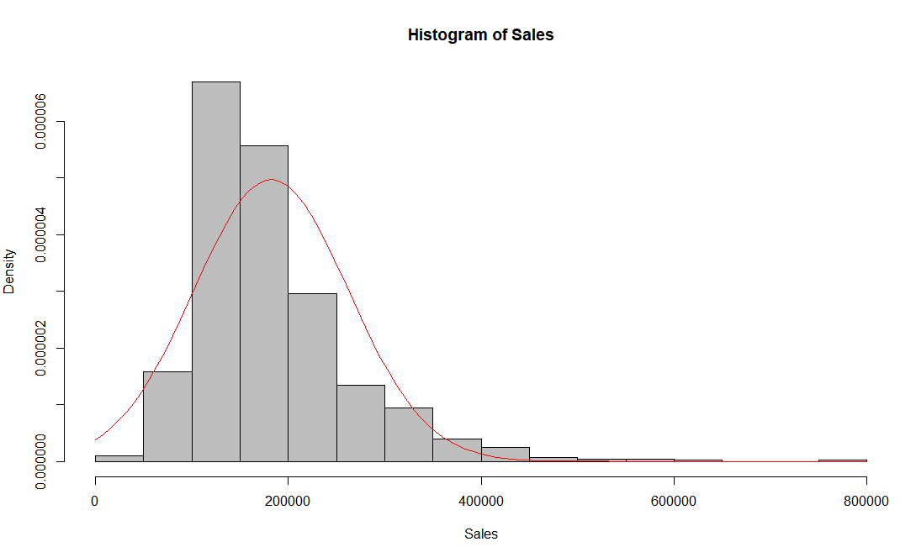
Figure 1.1. Histogram plot of sales prices

Remaining part of this study as follows. Section 2 introduces the data analysis part, AND section 3 discuss the model results.

DATA ANALYSIS

RESULTS

4. REFERENCES

